Computer Language Coding Concepts

Member Addition
The easiest technique for specialization by altering the member set is member addition. Here the concept of class inheritance is displayed:



Member addition means adding a member, that was not there in the base, but will be in the derived object:

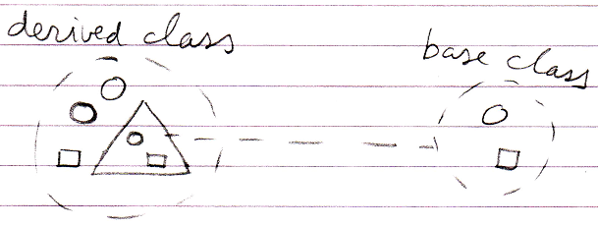

Author & Copyright: Jan-Joost van Zon Date: May 19, 2010 – July 17, 2010 Location: Oosterhout, The Netherlands Status: Finished

